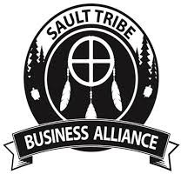
Boozhoo. The Sault Tribe Business Alliance was founded in 2018 by tribal member-owned business owners who recognized the need for an organized voice for our business community. The founding members foresaw an organization that would shape the tribal business community through active communication and the promotion of tribal member-owned businesses. As the STBA builds forward, we are striving to become a Chamber of Commerce for member-owned businesses, regardless of their location. We want others to understand there is a difference between tribal owned businesses (such as the casinos, Chippewa Government Solutions, Sault Tribe Inc.) and member-owned businesses.

We work to serve as a voice for our business community. STBA works to bring quality education and opportunities to our member-owned businesses, we are driven to support you and your business by providing networking, special events and growth opportunities.

Now in its 7th year, the STBA is stronger than ever and continues to help our tribal member-owned businesses build a community and have a collective voice. We are working to provide education and resources to our members and are working hard to bring amazing content to our members at our Annual Conference.

Whether you were a founding member, are an aspiring entrepreneur, are a tribal member-owned business owner/leader or are interested in becoming a new member, we encourage you to join the Sault Tribe Business Alliance and help us continue to serve as a voice for Native Owned Businesses. Membership includes but is not limited to:
- Free attendance to STBA events
- Company listing in the STBA Member Directory and on our website
- Access to the STBA Member Directory & contact information
- Opportunity to participate in conference calls/meetings
- Opportunities to provide training and education to our members
- Sponsorship opportunities to highlight your products and services to our members, sponsors and supporters
- Speaker opportunities

Should you have any questions, please do not hesitate to contact Rachel Mandelstamm, Membership Chair, at membership@stballiance.org. We appreciate your interest in Sault Tribe Business Alliance and look forward to serving as a voice for your business.

STBA MEMBERSHIP
Welcome To The Sault Tribe Business Alliance

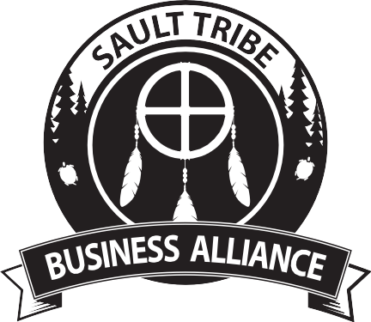

Why Join STBA?
Joining the Sault Tribe Business Alliance is a great way for Sault Tribe members who are business owners and leaders to participate in meaningful peer networking, educational programming and activities aimed at growing their business.

Mission
The Sault Tribe Business Alliance is dedicated to serving and supporting the success of Sault Tribe member- owned businesses and tribal member entrepreneurs through advocacy, access to leaders, mentors, growth opportunities, purposeful networking and business education.
Vision
Helping build a vibrant and prosperous tribal community through peer support to member-owned businesses and encouragement of tribal entrepreneurship.

Values
- Excellence

- Stewardship

- Integrity

- Inclusiveness

- Courage
In addition to our annual conference for STBA members, our goal is to oﬀer year-round opportunities that may include:
  - Listing in the STBA Membership Directory and on www.stballiance.org
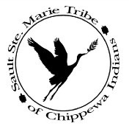
  - Training and education sessions on topics relevant to growing your Native-owned business and your
business leadership skills
  - Sponsorship opportunities that highlight your products and services with our members



STBA Objectives

Member Services



Get Involved with STBA!

We are always looking for assistance in support of our goal to expand resources, identify events aimed at growing businesses locally, regionally and/or nationally. Some areas where we welcome volunteers include:
- Annual conference committee

- Marketing committee

- Sponsorship

- Board Membership

- Recruiting new members
Have an idea you want to share for new programming, events, etc? Please let us know, we rely upon the recommendations of our membership to guide us in offering actionable support.

Email: membership@stballiance.org
Our members will have access to unique networking and promotional opportunities, educational programs, business services, and special events – all designed to help their business succeed.
Economic Development
Our economic development activities will feature the STBA as an active partner in the establishment and growth of member-owned businesses. We believe that business support tailored to tribal members-owned businesses is essential to creating a sustainable economy for our tribe.
Public Policy
The STBA will be a leading voice for member-owned businesses.
Community Vision
The STBA will play a leading role in shaping a powerful community of tribal member-owned business through the establishment of active peer to peer communication channels, the promotion of tribal member-owned business-to-business activities with an emphasis on supporting and expanding the Sault Tribe business environment.

Annual Dues Structure
Individuals (Tribal members) $50

Individual member beneﬁts: Free attendance at events with priority seating, able to join in on STBA conference calls and meetings with speaking rights.
Individuals (Non-Tribal members) $100

Individual member beneﬁts: Free attendance at events with priority seating, able to listen in to STBA conference calls but with no speaking rights.
Tribal-owned small business (50 employees or less) $100

Business member beneﬁts: Free attendance at events (three tickets) with priority seating, company listed as member, access to directory of all members with contact information. Will be contacted to take part in all alliance conference calls/meetings.
Tribal-owned big business (more than 50 employees) $250

Business member beneﬁts: Free attendance at events (eight tickets) with priority seating, company listed as member, access to directory of all members with contact information. Will be contacted to take part in all alliance conference calls/meetings.
Non-Tribal-owned business $400

Business member beneﬁts: Free attendance at events (three tickets) with priority seating, company listed as member, access to directory of all members with contact information. Will be contacted to take part in all alliance conference calls/meetings.
Corporate sponsor $1000

Corporate sponsor beneﬁts: Corporate sponsor logos will be included on promotional materials for all events as well as on newsletters. In addition, corporate sponsors will receive all of the beneﬁts of a Tribal-owned big business.

